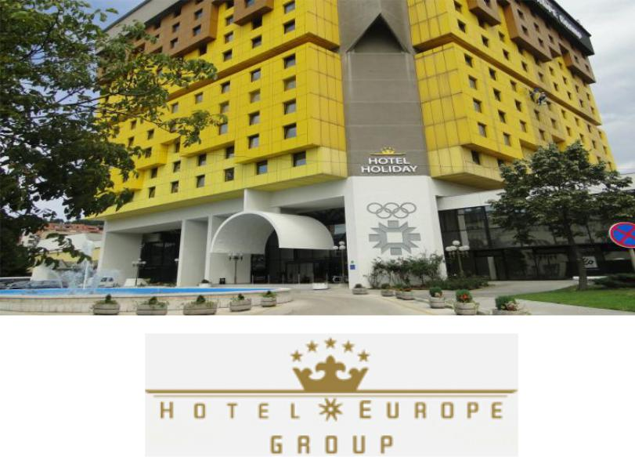

2018 IEEE PES ISGT Europe Conference
Hotel Reservation Form
Reservation code: 2017/ 2606
Please complete and return this form by e-mail (or by fax )to the hotel on the email address marketing@hotelholiday.ba (fax: 00387 33 288 288)
ACCOMODATION
HOTEL HOLIDAY**** |  | marketing@hotelholiday.ba |  |  | Reservation code: 2017 / 2606
Booking deadline 01.09. 2018.

Costs listed below are per room per night and include breakfast. Tax per day and insurance 2,50 BAM or 1,30 EUR is not included in room rate .
Type of Hotel Room:  ☐ Single bed room - 108,00 BAM / 55,21 EUR  ☐ Double bed room - 126,00 BAM / 64,43 EUR |  |  | Check In: Click here to enter a date.
 |  |  | Check Out: Click here to enter a date.
 |  |  | Number of Nights: Click here to enter text.
PERSONAL DETAILS
Title: Click here to enter text. |  |  | Participation: Click here to enter text.  (IEEE, Organizer, Keynote, Panelist, Author, Other)
Fist Name: Click here to enter text.
Last Name: Click here to enter text. |  |  | Passport Number: Click here to enter text.
Affiliation: Click here to enter text. |  |  | Expire Date: Click here to enter text.
City: Click here to enter text. | Country: Click here to enter text. |  |  | Email: Click here to enter text.
Special requirements:
IN ORDER TO GUARANTEE THIS BOOKING PLEASE PROVIDE US
Type of Card: ☐ Visa ☐ MasterCard ☐ American Express ☐ DISCOVER
Credit Card Number: Click here to enter text.
Expiration Date: Click here to enter a date.
NOTE: In case of cancellation of the room reservation, please inform us 2 days before guests arrival. Otherwise we charge from your credit card 1st night of the costs for the guests stay.

