Title of the poster abstract
First A. Author¹, Fellow, IEEE, Second B. Author², and Third C. Author, Jr.², Member, IEEE
¹National Institute of Standards and Technology, Boulder, CO 80305 USA
²Department of Physics, Colorado State University, Fort Collins, CO 80523 USA

Keywords Enter up to 5 keywords, separated by commas.
Background Introduce your work. Overall, please consider to stay in two pages maximum. This is not your poster, but the abstract of your poster that will be distributed to the participants during the summer school. It is important that the students put their picture and details for networking purposes. Even people not presenting anything are required to compile the table below with their details.
Aims This study aimed to… References should be cited as [1]. Avoid using bullet points and numbered lists. Avoid Bold and use Italic if you need to emphasize something.
$$E=mc^{2}$$ | (1)
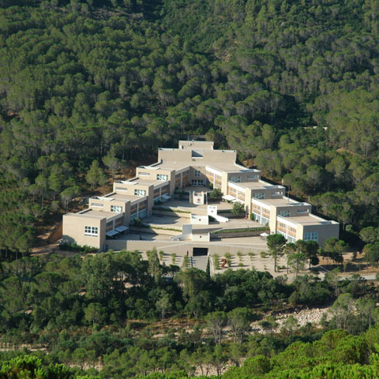
Materials and Methods What are you presenting. If you need to put a figure, just align it with the text around and provide a caption in this way. Equations should be inserted into tables with proper numbering, by equation editor.
Figure 1: Insert the caption with the Reference -> Insert Caption feature

Results Put the main results and comments on them
Conclusion Briefly conclude your work
Bibliography
[1] Sameni, R., Clifford, G. D. (2010). A review of fetal ECG signal processing; issues and promising directions. The open pacing, electrophysiology & therapy journal, 3(4). DO NOT PUT MORE THAN 2-3 REFERENCES

Danilo Pani, Ph.D. (put a 3 cm × 3 cm picture of you)
Assistant Professor of Bioengineering (your academic/working position)
Eolab, Microelectronics and Bioengineering Lab
Department of Electrical and Electronic Engineering
University of Cagliari
Cagliari, Italy
e-mail: pani@diee.unica.it (Mandatory)
website: people.unica.it/danilopani (if any. Optional)
mobile: +39 320 437 3041 (for whatsapp group. Optional)

